# CC20-logo-horizontal-rgb-large

The Cochrane Collaboration

Chief Executive Officer  
Summertown Pavilion   
18-24 Middle Way

Oxford  
 OX2 7LG UK

Tel: +44 (0)1865 310138

Fax: +44 (0)1865 316023

E-mail: [mwilson@cochrane.org](mailto:mwilson@cochrane.org)

[www.cochrane.org](http://www.cochrane.org) www.thecochranelibrary.com

# Summertown Pavilion, 18-24 Middle Way

Oxford OX2 7LG

Professors Thomas Middelboe, Merete Nordentoft,

Poul Videbech & Lars Vedel Kessing,

Copenhagen,

Denmark

Thursday 20th March 2014

Dear Professors Middelboe, Nordentoft, Videbech & Kessing,

Thank you for your letter of March 5th that was sent to the Co-ordinating Editors of the Cochrane Schizophrenia and Depression-Anxiety Review Groups. We are writing to you as the leaders of The Cochrane Collaboration and on behalf of both Professor Adams and Dr Churchill.

Cochrane is treating very seriously the points you raise concerning comments made by Professor Gøtzsche on the use of psychotropic medication. I want to state explicitly that these are not the views of The Cochrane Collaboration on this issue and we do not endorse them.

Professor Gøtzsche was therefore speaking only for himself in the articles and video featured on the websites you highlighted - part of the promotional work he conducted surrounding publication of his book, ‘Deadly Medicines and Organised Crime: How big pharma has corrupted healthcare’. The views contained in this book are also not the views of Cochrane. We have therefore written to Professor Gøtzsche asking him to make clear in all future communications to any reader or listener that these views on psychotropic medication are his own and cannot be considered to represent the views of the Collaboration.

This incident has highlighted to us that Cochrane needs to establish a more formalised policy and position-making process that would result both in a small set of explicit advocacy and policy positions the organisation holds and campaigns for; and a set of guidelines to ensure the 31,000 Cochrane Collaborators around the world have clear guidance on how to differentiate when they are representing these positions, and when they speak on any other personal views they may hold. We expect this process to be completed and in place this year.

We are as committed as you are to ‘providing the safest and most efficient treatment possible’ to patients around the world; and we welcome your openness to critique and to ‘share the challenges of psychiatric treatment and try to improve patient results’. We will be asking Professor Gøtzsche to share with Cochrane colleagues any unpublished data that is not yet publicly available, so that it can be incorporated objectively into new or existing Cochrane Systematic Reviews as appropriate; and then be seen and evaluated by you and other specialists in the field.

Once again, our grateful thanks for drawing our attention to this issue.

Yours sincerely,

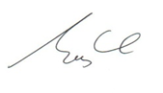

**Jeremy Grimshaw                                                                           Mark Wilson**

Co-Chair                                                                                            CEO

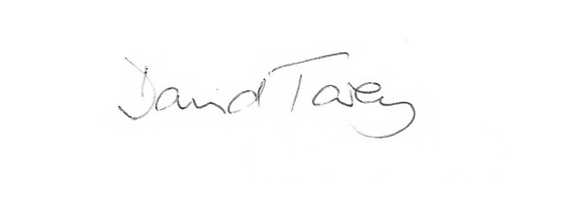

**Lisa Bero                                                                                           David Tovey**

Co-Chair                                                                                            Editor-in-Chief